Mobile Device Enrollment Directions

If you do not enroll your mobile device with Microsoft Endpoint Manager (MEM), formerly named Intune, you will not be able to access NTTGN email or data on your mobile device after 16 October 2022.
*Important NOTE: Enrolling your phone will not give NTTGN the ability to wipe your personal data, control your phone, or even retrieve your phone number. It creates a “sandbox” on your phone where apps and accounts held in that “sandbox” can securely interact with NTTGN email and cloud data.

The MEM Mobile Device management (MDM) solution will prevent you from copying NTTGN data and using it outside of the “sandbox” of NTTGN managed apps on your device. It will also require you to install and use approved apps to read email (Outlook mobile app) and interact with data (such as OneDrive and SharePoint) that are relevant to perform your work functions.

If you open a link to a Zoom or Teams meeting, you’ll need to install that software from the Company Portal app after you enroll. Instructions on how to install the necessary software are included below. If Outlook is already installed on your mobile device, you will still need to install the Outlook Mobile App from the Apple Store or Google Play Store to read company email. Doing so will install it to the “sandbox” and allow you to access your email.

Here are some notes that will help this be successful and eliminate confusion:

- If you already have your NTTGN email account on your phone, you’ll need to remove it first.
  - Click here for iPhone directions: iPhone Directions
  - Click here for Android directions: Android Directions
- Another prerequisite is to install the Company Portal App (this is included in the directions below). You should install the Company Portal App from your appropriate App store, but read through the below enrollment directions before setting it up or logging in to it.
- Please read the entire directions and watch the video at the link below before executing them. It will help if you have read through them first.

iPhone Directions:

Video of the enrollment process: Enroll your iOS device in Microsoft Intune - Bing video
Directions of the enrollment process: Set up iOS device access to your company resources | Microsoft Learn

Android Directions:

Video of the enrollment process: Set up Android Work Profile on your device using Microsoft Intune - YouTube
Directions of the enrollment process: Enroll device and create Android work profile - Microsoft Intune | Microsoft Docs

After you have completed the appropriate direction above and have installed the Outlook app from the Company Portal, you will also need to install the Contacts App so you can sync your contacts back to your phone. After the Contacts app is installed, you’ll need to open Outlook and ensure that the “Save Contacts” option is enabled. Please see the next page for directions on how to turn that on if it isn’t:
How to turn on Contact Syncing in Outlook to your phone’s Contact app

- Open the Outlook app on your iPhone.
- Tap your profile icon in the top-left corner of the screen. Then tap Settings (the gear icon).
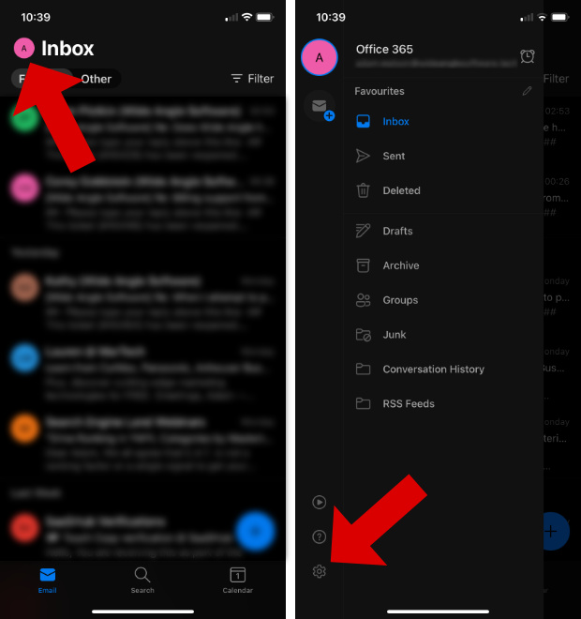

- Select your Outlook account.
- Next to "Save Contacts", toggle the slider to the ON position.
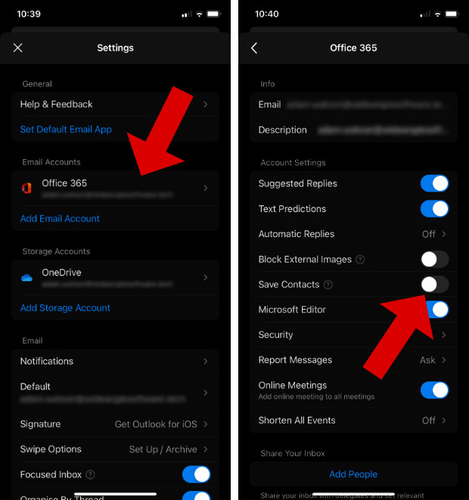
- You'll receive a message asking if you'd like to save your Outlook contacts to your iPhone. Ensure your iPhone is plugged into to power, then tap "Save to my iPhone".

